Birth Records Data Quality Assessment
Generated: 2026-03-31 19:29
Dataset: 363,881 birth records × 18 variables

1. Executive Summary
This report presents a comprehensive analysis of missing values in the birth records dataset.
Key findings include:
• **Dataset Overview**: 363,881 total birth records with 18 variables
• **Data Completeness**: 318,290 records (87.5%) are completely filled with no missing values
• **Records with Missing Data**: 45,591 records (12.5%) contain at least one missing value
• **Total Missing Values**: 45,850 missing values across all variables (0.7% of all data)
• **Average Completeness**: Each record has an average of 0.13 missing values
• **Maximum Missing**: The record with most missing data has 2 missing values
• **Variables with Missing Data**: 3 out of 18 variables have missing values
• **Critical Variables**: ['Birth_Weight(grams)', 'Race_of_Father', 'Birth_Order'] have the highest missing rates

2. Summary Statistics
Metric | Value
Total Rows | 363881.0
Total Columns | 18.0
Columns with Missing Data | 3.0
Total Missing Values | 45850.0
Overall Missing % | 0.7
Complete Records (No Missing) | 318290.0
Incomplete Records (≥1 Missing) | 45591.0
Complete Records % | 87.47
Incomplete Records % | 12.53
Average Missing per Row | 0.13
Max Missing in Single Row | 2.0

3. Complete Birth Records (No Missing Values)
Found 318,290 completely filled birth records (87.5% of total). These records can be used for immediate analysis without imputation.
Complete records have been exported to the "Complete Records" sheet in the accompanying Excel file (01_missing_values_analysis.xlsx).

4. Incomplete Birth Records (With Missing Values)
Found 45,591 records with at least one missing value (12.5% of total). These records require data imputation or careful handling in analysis.
Incomplete records have been exported to the "Incomplete Records" sheet in the accompanying Excel file (01_missing_values_analysis.xlsx).

5. Missing Values by Variable
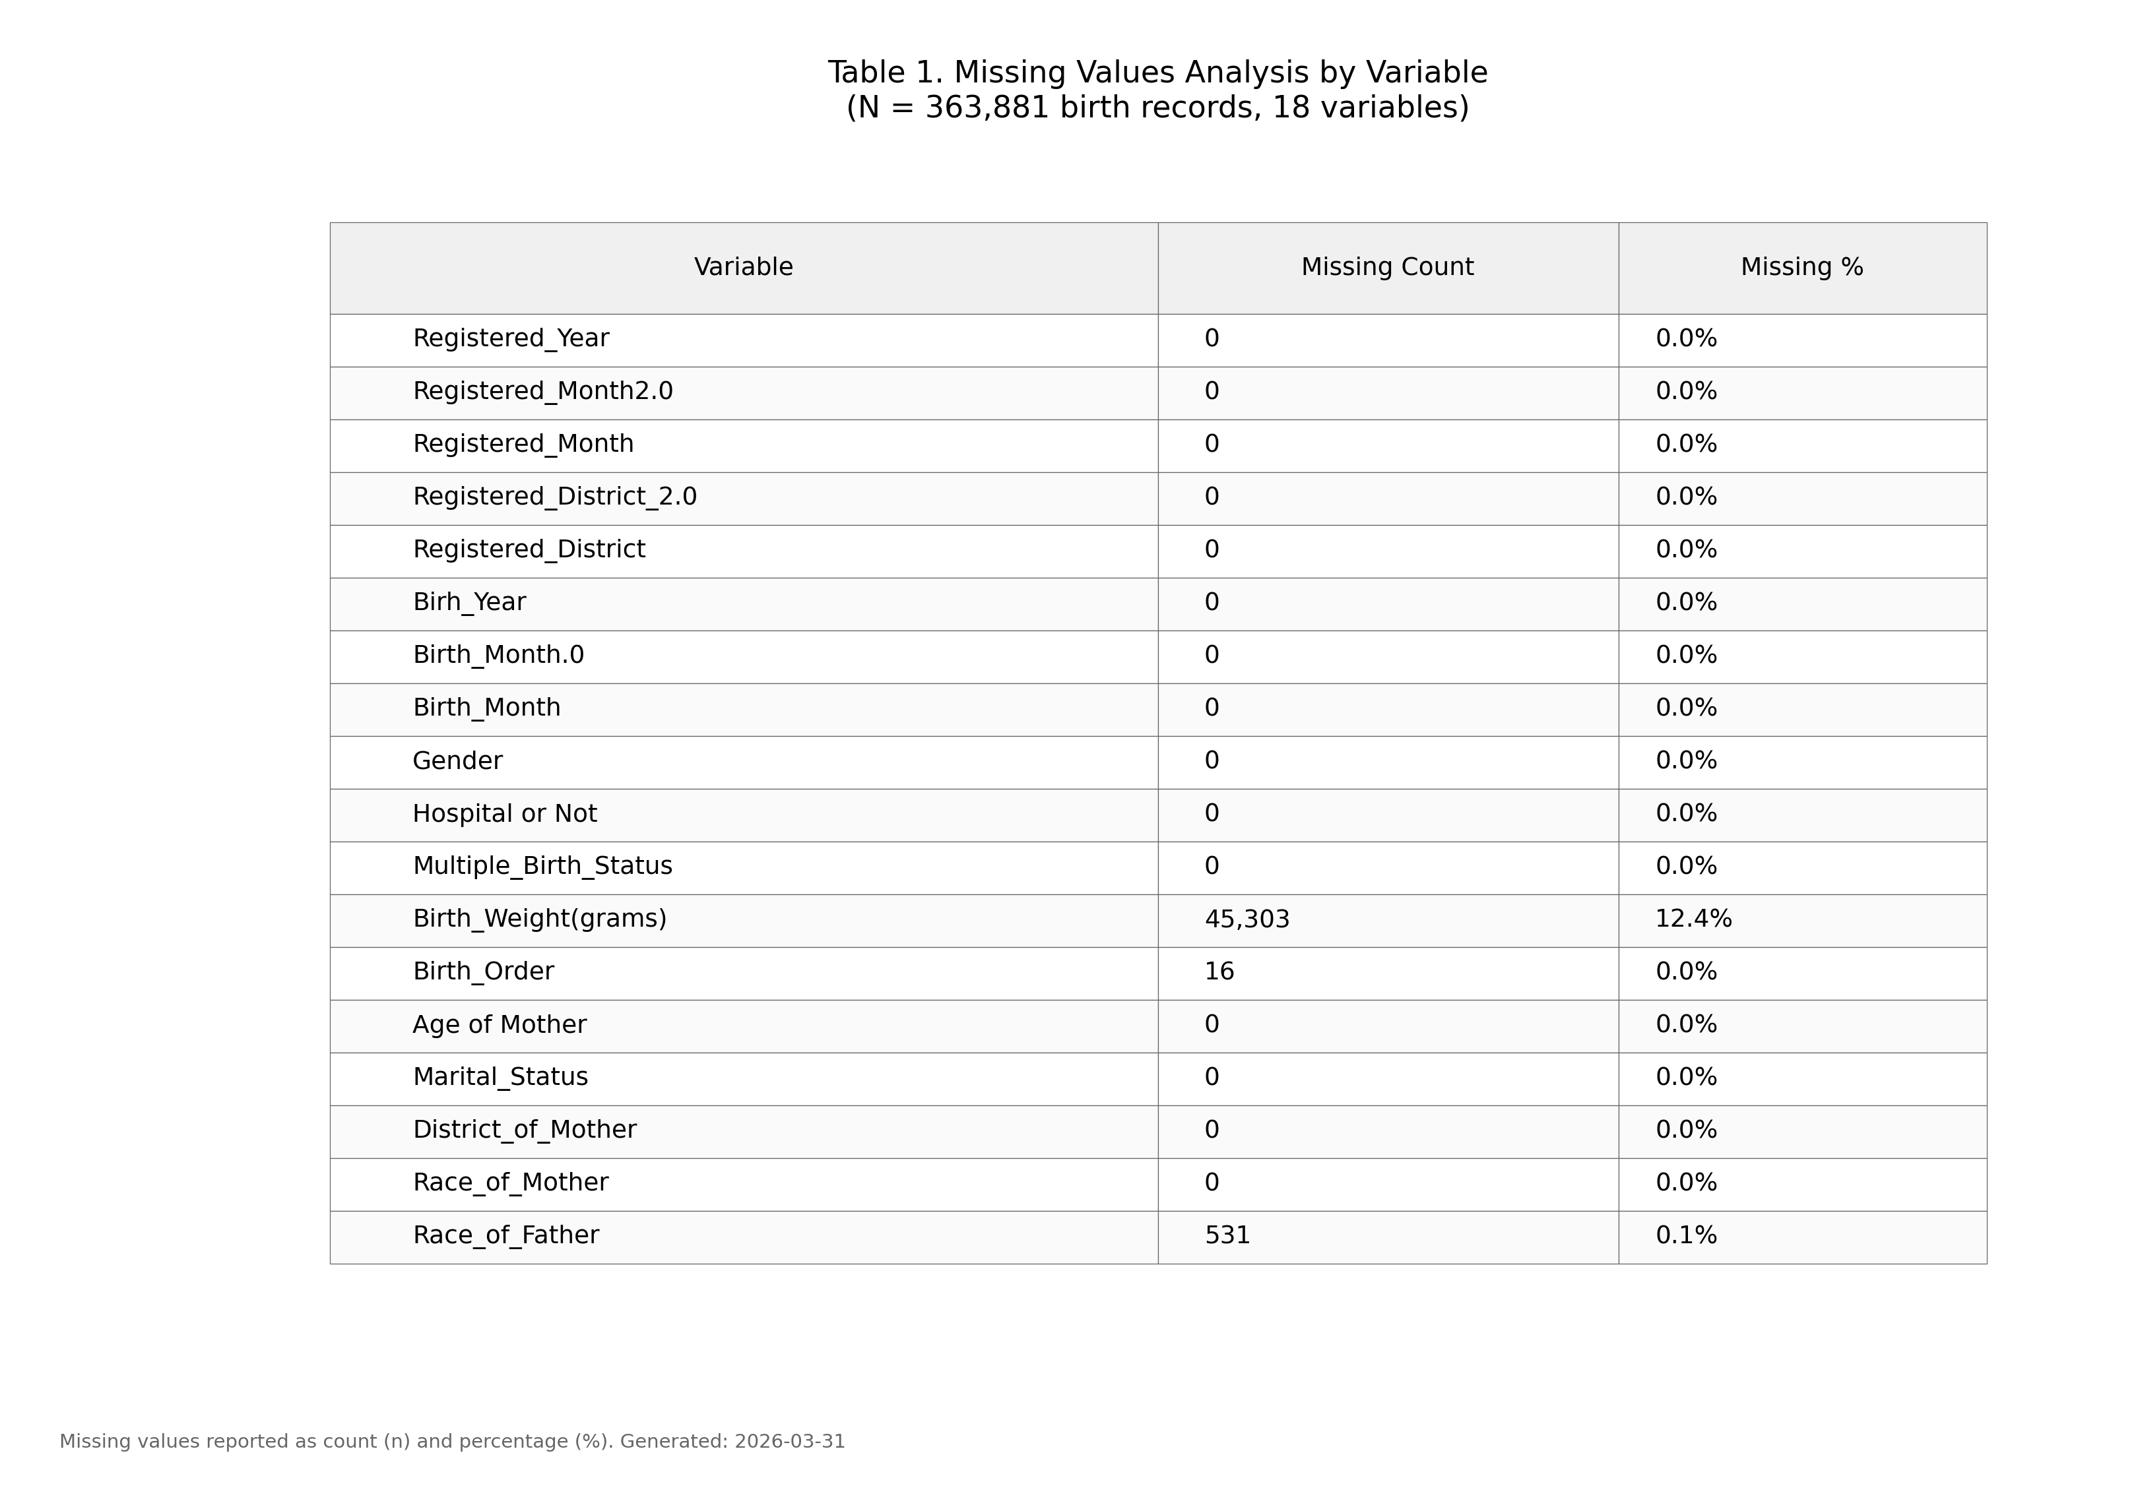
Figure 1. Missing values by variable (IUPAC compliant formatting).

6. Row-Level Missing Distribution
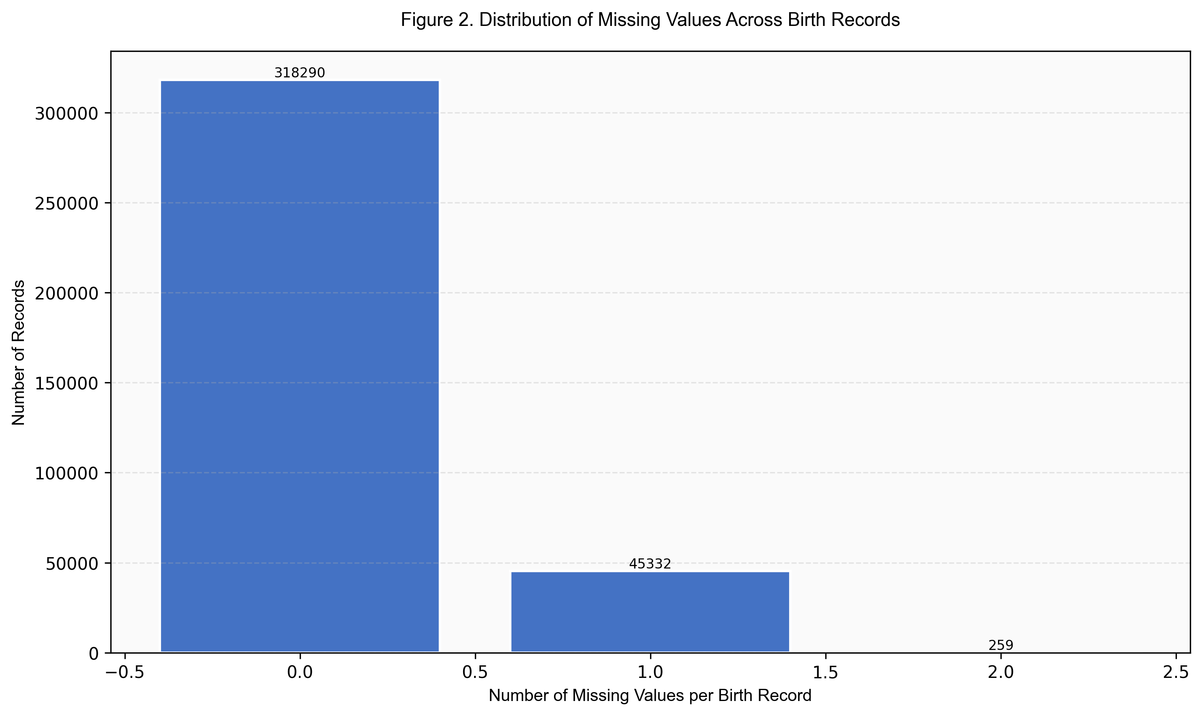
Figure 2. Distribution of missing values across birth records.

7. Detailed Missing Values by Variable
The following table shows missing value counts and percentages for each variable. Variables are sorted by missing count (highest to lowest).
Variable | Missing Count | Missing % | Data Type | Unique Values | Non-Missing | Completion %
Birth_Weight(grams) | 45,303 | 12.4% | float64 | 2,275 | 318,578 | 87.6%
Race_of_Father | 531 | 0.1% | str | 12 | 363,350 | 99.9%
Birth_Order | 16 | 0.0% | str | 9 | 363,865 | 100.0%
Registered_Year | 0 | 0.0% | int64 | 1 | 363,881 | 100.0%
Registered_Month2.0 | 0 | 0.0% | int64 | 12 | 363,881 | 100.0%
Registered_Month | 0 | 0.0% | str | 12 | 363,881 | 100.0%
Birth_Month.0 | 0 | 0.0% | int64 | 12 | 363,881 | 100.0%
Registered_District_2.0 | 0 | 0.0% | int64 | 25 | 363,881 | 100.0%
Registered_District | 0 | 0.0% | str | 25 | 363,881 | 100.0%
Birh_Year | 0 | 0.0% | int64 | 60 | 363,881 | 100.0%
Hospital or Not | 0 | 0.0% | str | 2 | 363,881 | 100.0%
Gender | 0 | 0.0% | str | 2 | 363,881 | 100.0%
Birth_Month | 0 | 0.0% | str | 12 | 363,881 | 100.0%
Multiple_Birth_Status | 0 | 0.0% | str | 2 | 363,881 | 100.0%
Age of Mother | 0 | 0.0% | int64 | 43 | 363,881 | 100.0%
Marital_Status | 0 | 0.0% | str | 2 | 363,881 | 100.0%
District_of_Mother | 0 | 0.0% | str | 26 | 363,881 | 100.0%
Race_of_Mother | 0 | 0.0% | str | 12 | 363,881 | 100.0%

8. Recommendations
- Based on the missing values analysis, the following approaches are recommended:
- Use the 318,290 complete records for immediate analysis where possible
- Variables with <5% missing: Consider mean/median imputation or listwise deletion
- Variables with 5-20% missing: Multiple imputation recommended
- Variables with >20% missing: Consider exclusion or create "missing indicator" variable
- For birth records with missing values, consider:
- • Records with 1-2 missing values: Mean/mode imputation
- • Records with 3-5 missing values: Multiple imputation
- • Records with >5 missing values: Consider exclusion or sensitivity analysis

9. Methodology
Analysis performed according to IUPAC guidelines for data presentation:
- • Missing values reported as both count (n) and percentage (%)
- • Row-level analysis includes identification of complete and incomplete records
- • Tables formatted with thin gray borders and alternating row shading
- • Sans-serif fonts (Arial) used for optimal readability
- • Figures saved at 300 DPI for publication quality
- • Complete data available in accompanying Excel file with multiple sheets

